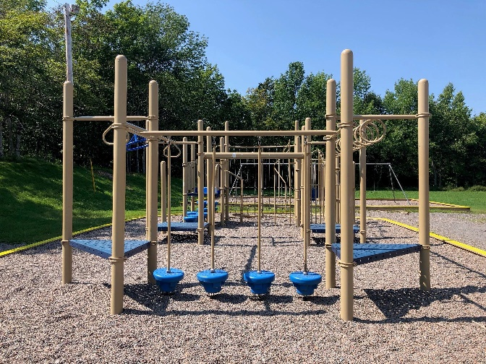
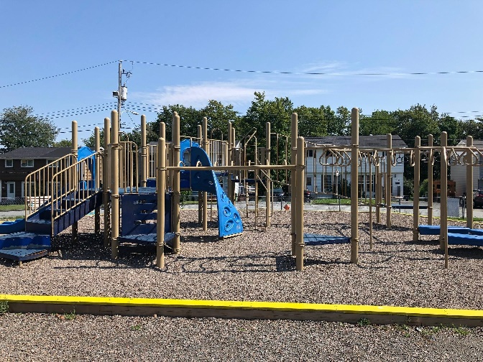

Welcome to the 2023-2024
School Year
Smokey Drive Elementary School

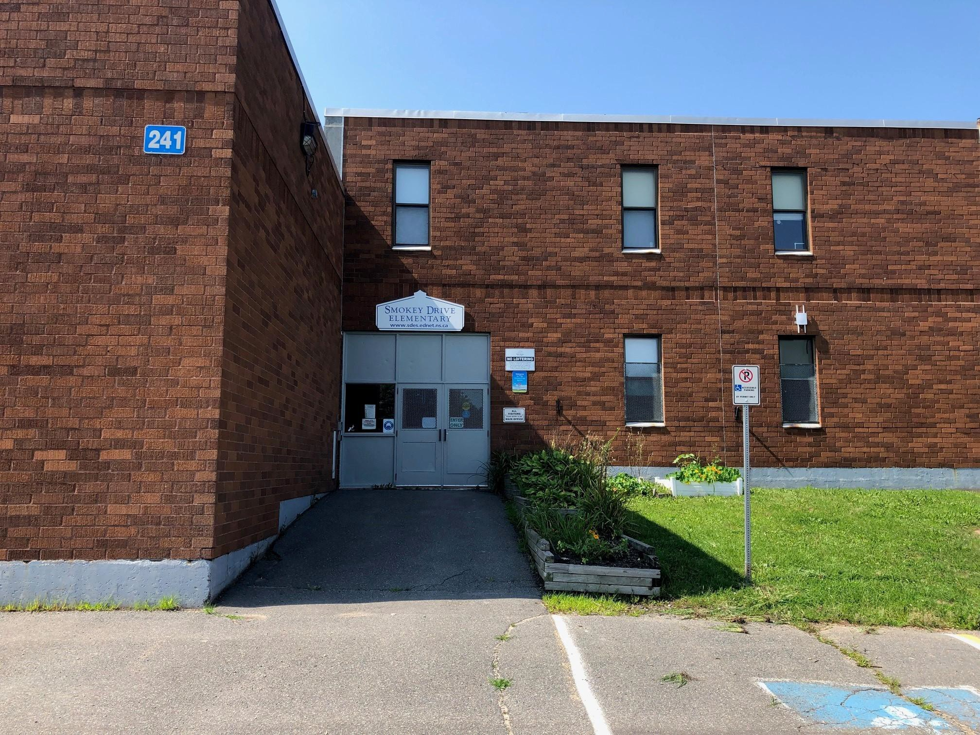
241 Smokey Drive, Lower Sackville, NS Main Ofﬁce: 902-864-6838
Safe Arrival: 1-833-582-6940
Website: https://sde.hrce.ca/
Email: sdes@hrce.ca Twitter: @SmokeyDrive

Administrative Staff
Principal: Mrs. J Miller
Vice Principal: Ms. E Quigley Admin Assistant: Ms. L MacNeil Counsellor: Ms. W Camellato

Introduction

We want to welcome all our returning and new families to the 2023-2024 school year. We are excited to begin a new year of learning with our students. Whether you are a new family or returning family, we look forward to getting to know you and your children. I am happy to share that Ms. Emily Quigley will be acting vice principal until March Break. Ms. Carolyn LeBlanc will join us in this role after March Break. I know both will love being a part of the Smokey Drive community.

We are sending this message to our families to give you information about the return to school. You will be receiving more communications about school routines and other newsletter information in the coming weeks.

- School arrival times: Students are welcome to arrive between 8:15 and 8:30 and will enter the school as soon as they arrive. Teachers will welcome and supervise their students in their classrooms until classes begin at 8:35. Dismissal time is 2:30.
- Please use the walkway entry that is located on Smokey Dr and not the driveway entrance as you arrive for drop off and pick up. Once families arrive, we ask that you stay on the playground areas so as not to block any of the driveway. The driveway is a busy spot each day as staff arrive and we want to ensure the safety of all.
- First day of school entrances: all grades 1-5 students should enter using the front door and go directly to their classrooms. We are asking families to say their goodbyes outside. Staff will be at the entrances to assist students with finding their classrooms. Pre-primary and primary students will meet in the gymnasium. Please use the outside gym door to enter on this day only.
- Please send a filled water bottle to school with your child each day.
- Remember to dress for the weather. We will be outside at recess and lunch even during light rain and mist.
- An extra set of clothing to keep in the backpack is always a great idea.
- If lunch requires cutlery, please include that in your child’s lunch bag.

Class Placements
The creation of class lists is always a collaborative task. Last spring, teachers, including classroom, specialist and resource, worked together to balance our classes. They take many factors into account when making up lists, including class caps, strengths and needs of each student, healthy peer support, etc. Class changes are not possible.
Teachers will be in contact with the families of their students on Tuesday, Sept 5. This may be via email or phone call. If you check PowerSchool to see your child’s teacher, please be aware that due to new registrations that are still being processed, there may be changes. You will be contacted by your child’s teacher to confirm which class they are in. The child’s teacher will also share information regarding classroom numbers and pick up on the first day of school.
School Hours
8:15 – the earliest that students can be on the school grounds. There is no supervision prior to 8:15am. Students should arrive between 8:15 and 8:30 to ensure they are ready to learn when classes begin at 8:35.
8:35- classes begin
10:10-10:25 – recess
12:05-1:00 – lunch * this is a new time for the 2023-24 year*
2:30 - dismissal

Medical Needs
For those families that have children with life threatening allergies or health concerns, we will be sending out paperwork to you. If you have a child with life threatening allergies (anaphylaxis) or other health concern and did not receive the paperwork yet, please reach out and we will send that along to you.

Welcome to school/Curriculum Event
We welcome all P-5 students to school on Wednesday, Sept 6 from 4:30-6pm. This will give students and families the opportunity to meet the teacher, find the classrooms and drop off supplies. We hope this will help to alleviate any “first day jitters”. Teachers will send home more specific curriculum information later on in the month of September.

Employment Opportunities
Lunch monitors are needed to support our students. This is a paid position from 12:00-1:00 daily. If you are interested, or know someone who is interested, please call the main office at 902-864-6838 or email Lesley MacNeil at lmacneil@hrce.ca.
We are willing to consider part-time as well as full-time candidates.

Safe Arrival
We do attendance each day to make sure that students have safely arrived at school. Phone calls are made to parents/guardians if students are absent, and we have not received notiﬁcation of the absence. It is very important you call or email our Safe Arrival system prior to 8:35am if you child will be absent.
Phone: 1-833-582-6940
Parent Portal of Powerschool https://sishrsb.ednet.ns.ca/public/

Upcoming Dates

Sept 1 – Organization Day
Sept 4 – Labour Day
Sept 5 & 6 – Professional Development Days
Sept 6- Welcome to school event 4:30-6:00pm
Sept 7 – First day of school for students
Sept 13- SAC 6pm/PTA 7pm meetings
Sept 14- Stand Up Against Bullying Day – wear pink/PTA Welcome Event
Sept 21- Picture Day
Sept 29- Orange Shirt Day
Sept 30- Truth and Reconciliation Day
Oct 2- Truth and Reconciliation Day observed- no school for students and staff

I can’t wait to welcome our students and families on Sept 6th. I am looking forward to another wonderful year of learning and growing together. See everyone soon.
Respectfully,
Jeannie Miller
Principal

